**Naive Bayes application**

# Step 1: Open weka explorer

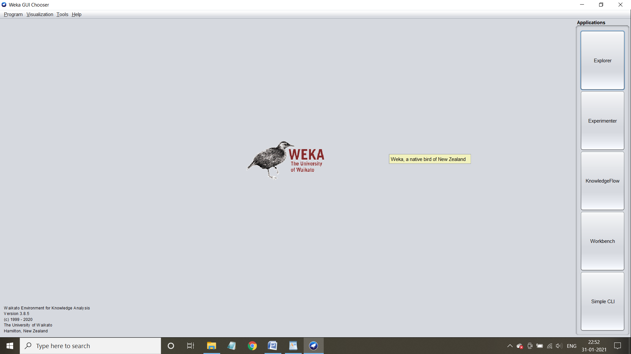

Step 2: Load German credit data set into weka

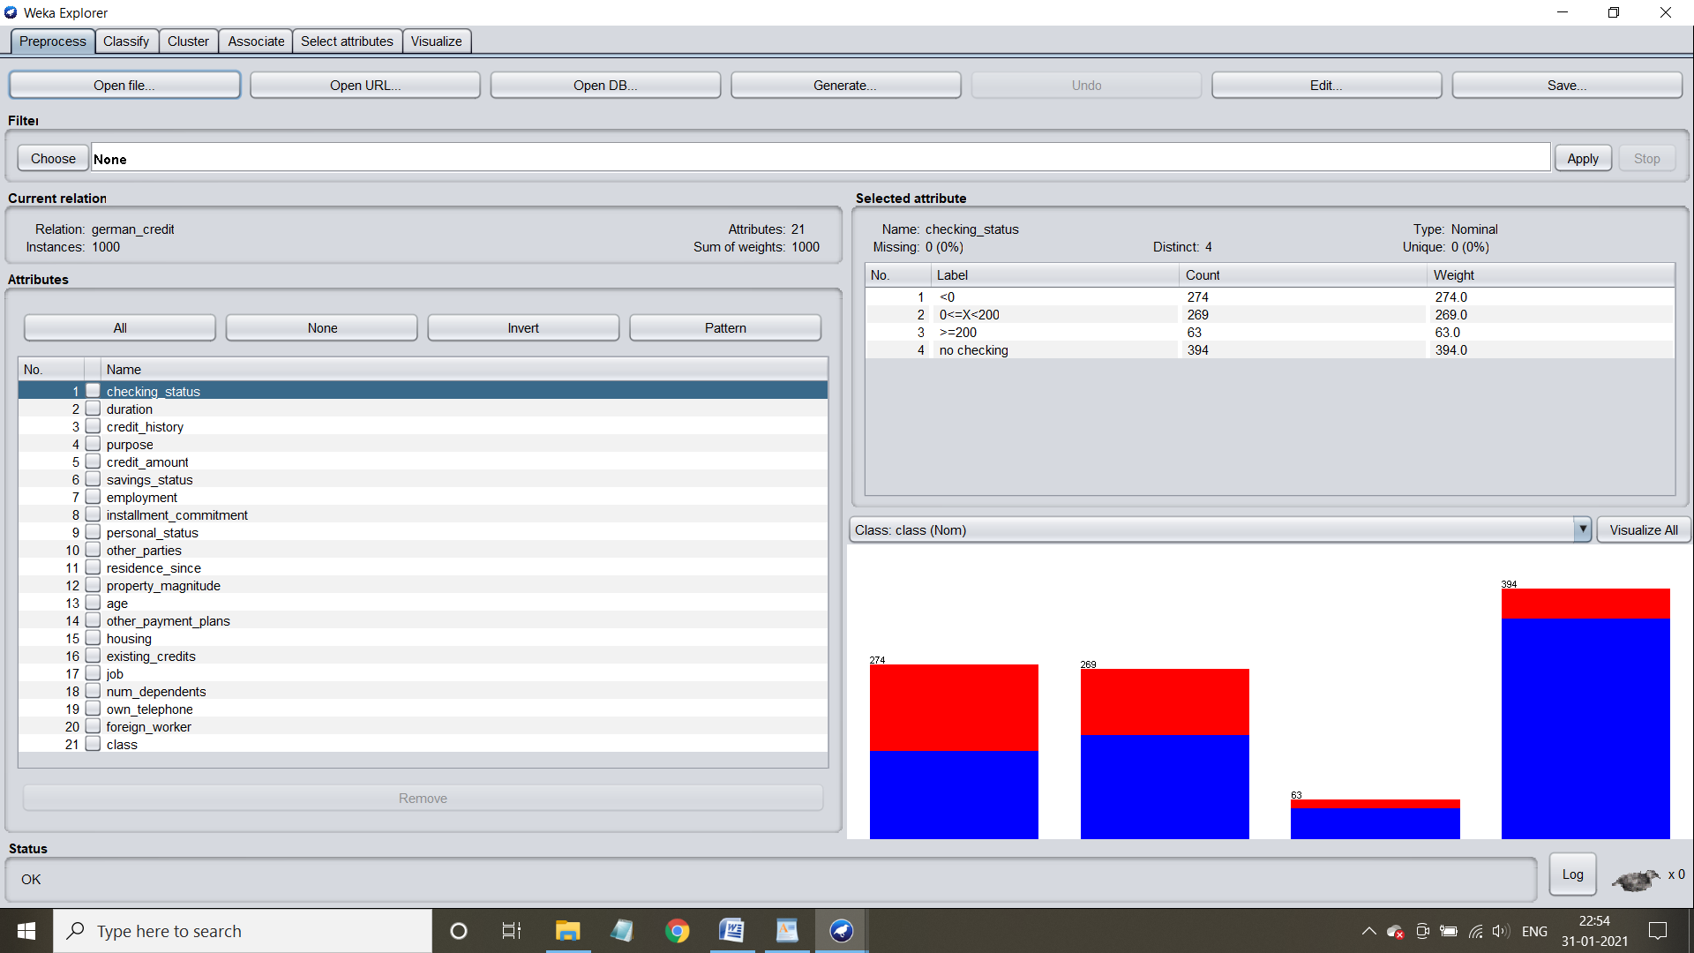

3. Select the classify tab and choose naive bayes option

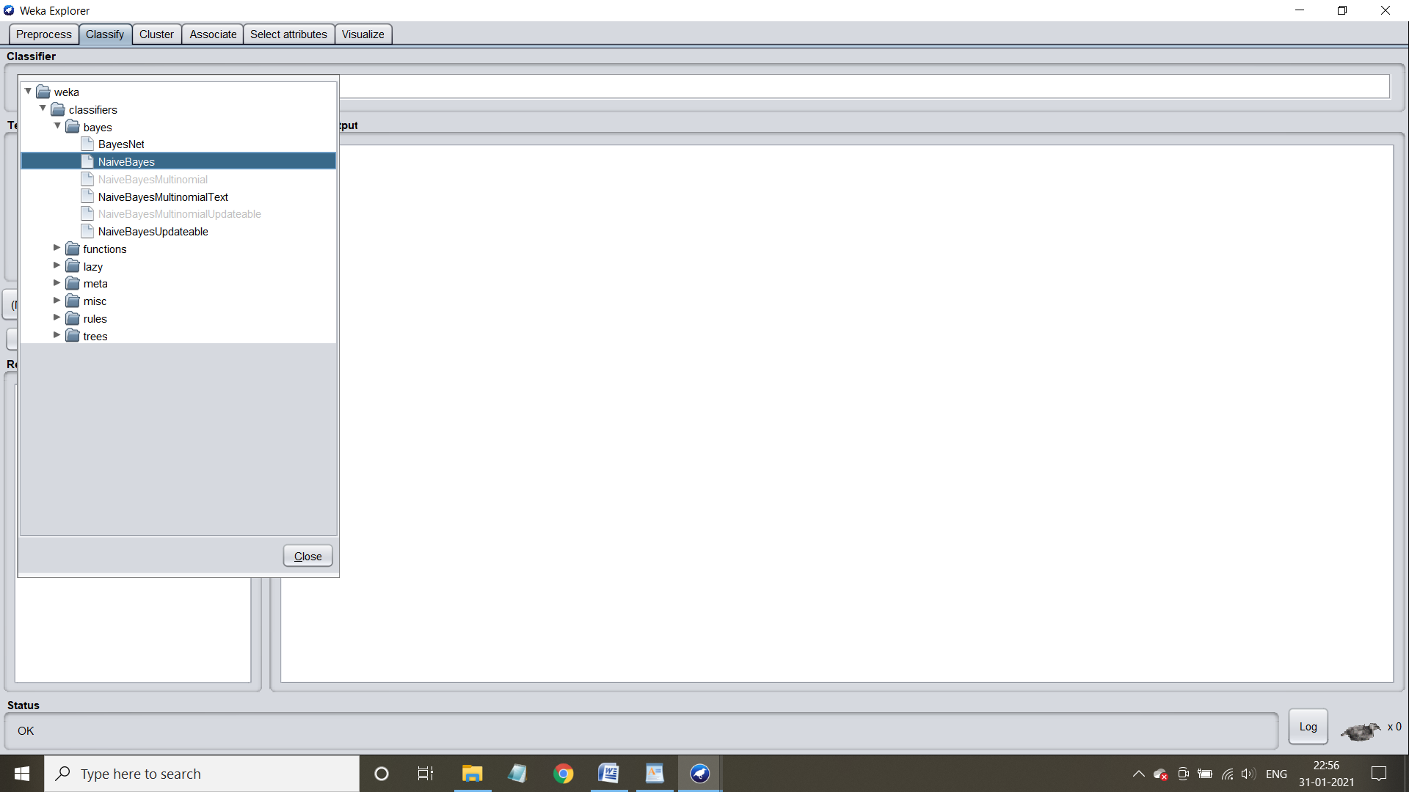

**Application of Naive bayes using training set**

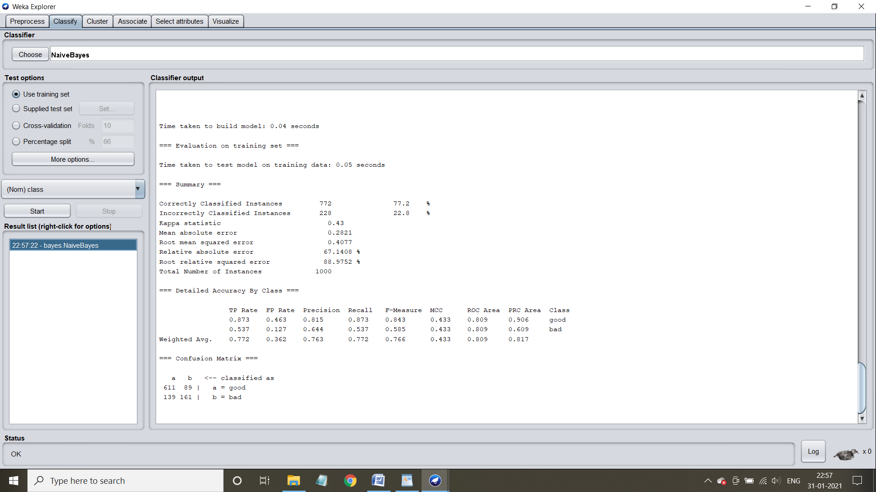

Step 2: Understand the characteristics of the algorithm

Time taken to bulid the model = 0 seconds

Time taken to test the model on the training data = 0.05 seconds

**Confusion matrix and accuracy**:

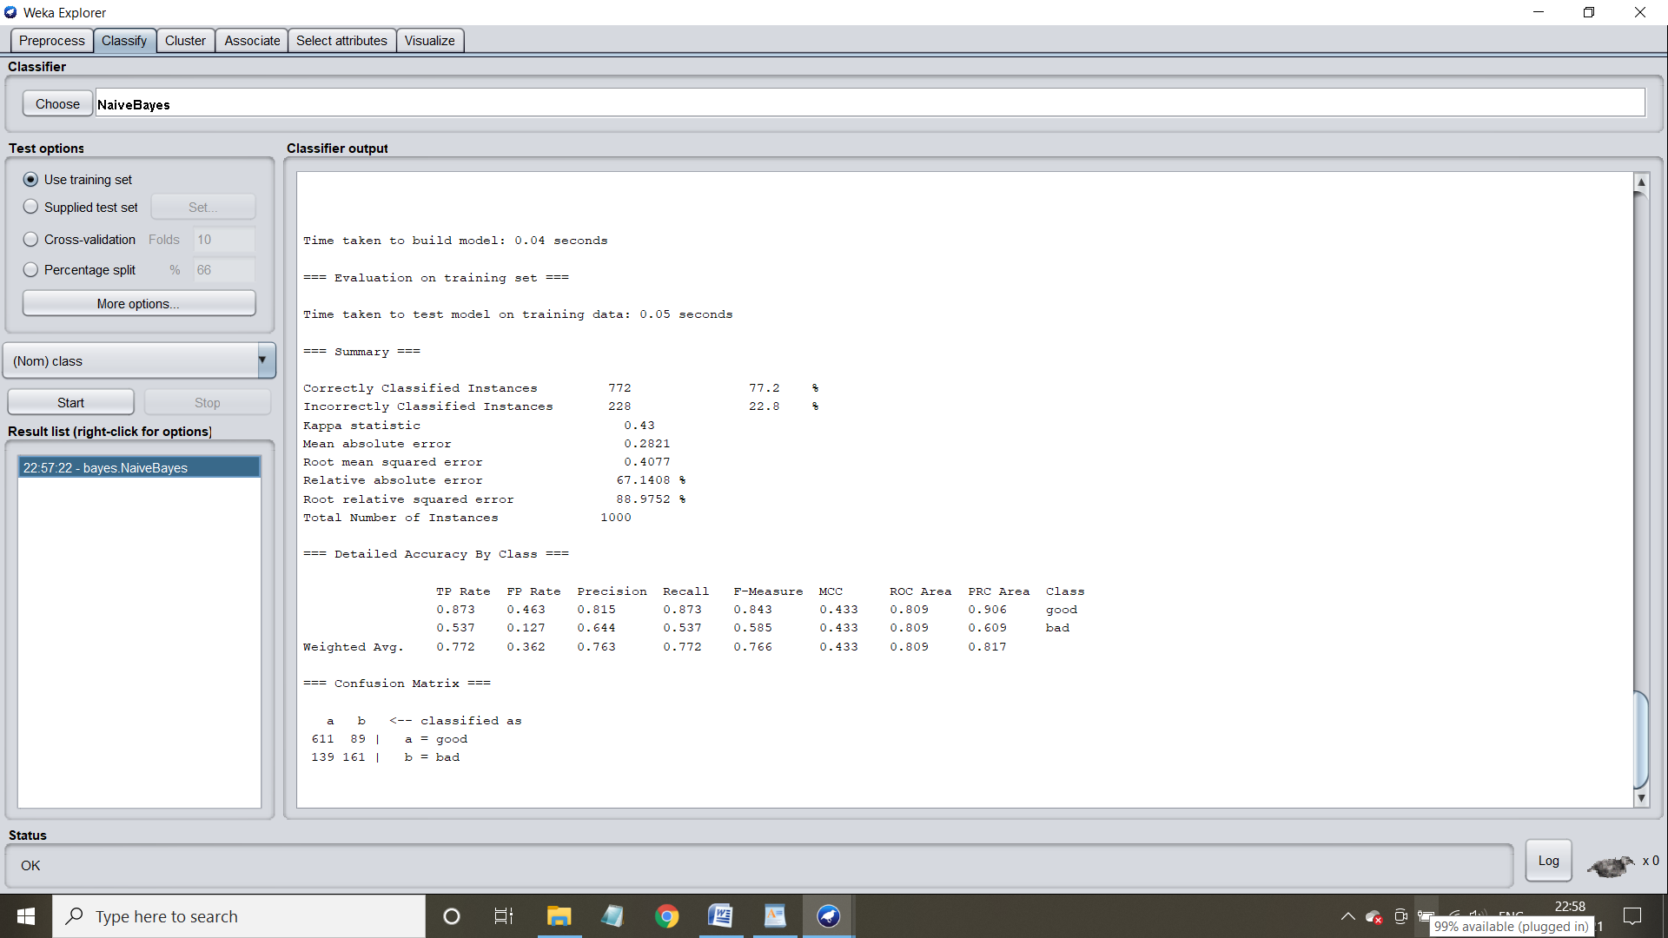**Visualization of the model - Margin Curve:**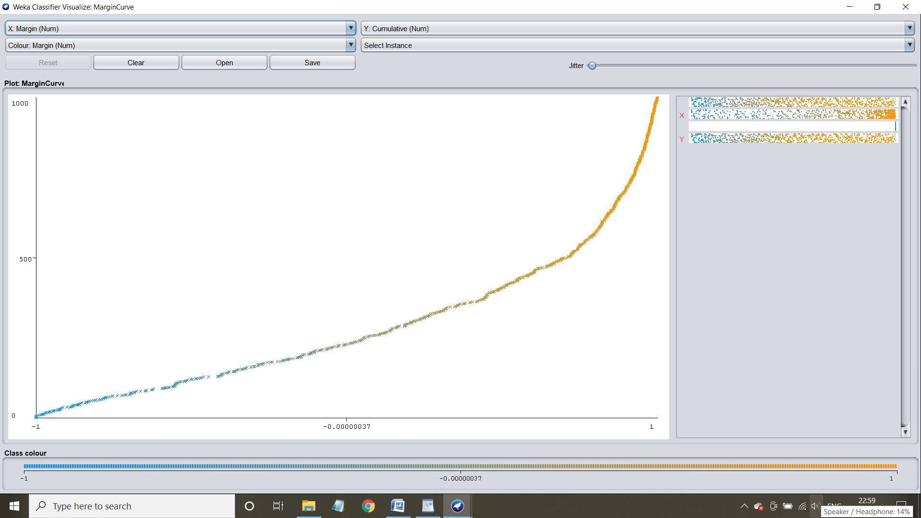

**Threshold curve for the class: Good**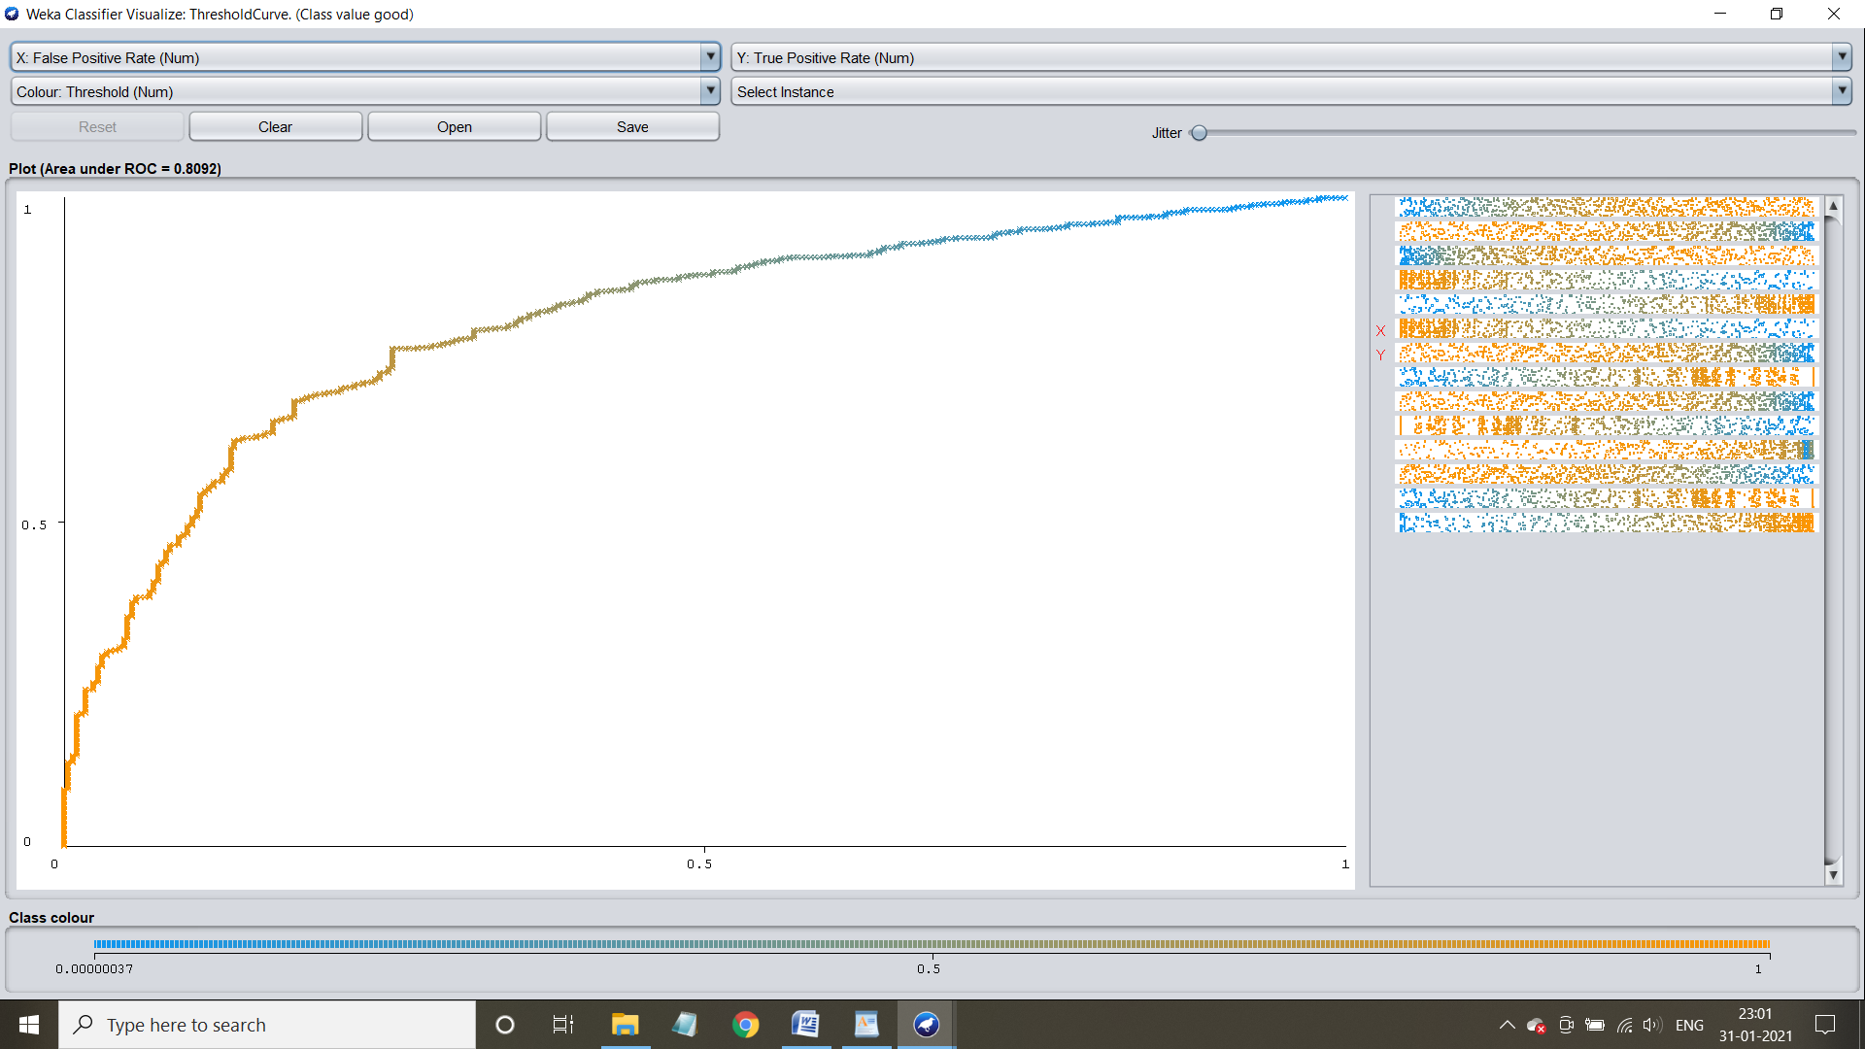

**Threshold curve for class: Bad**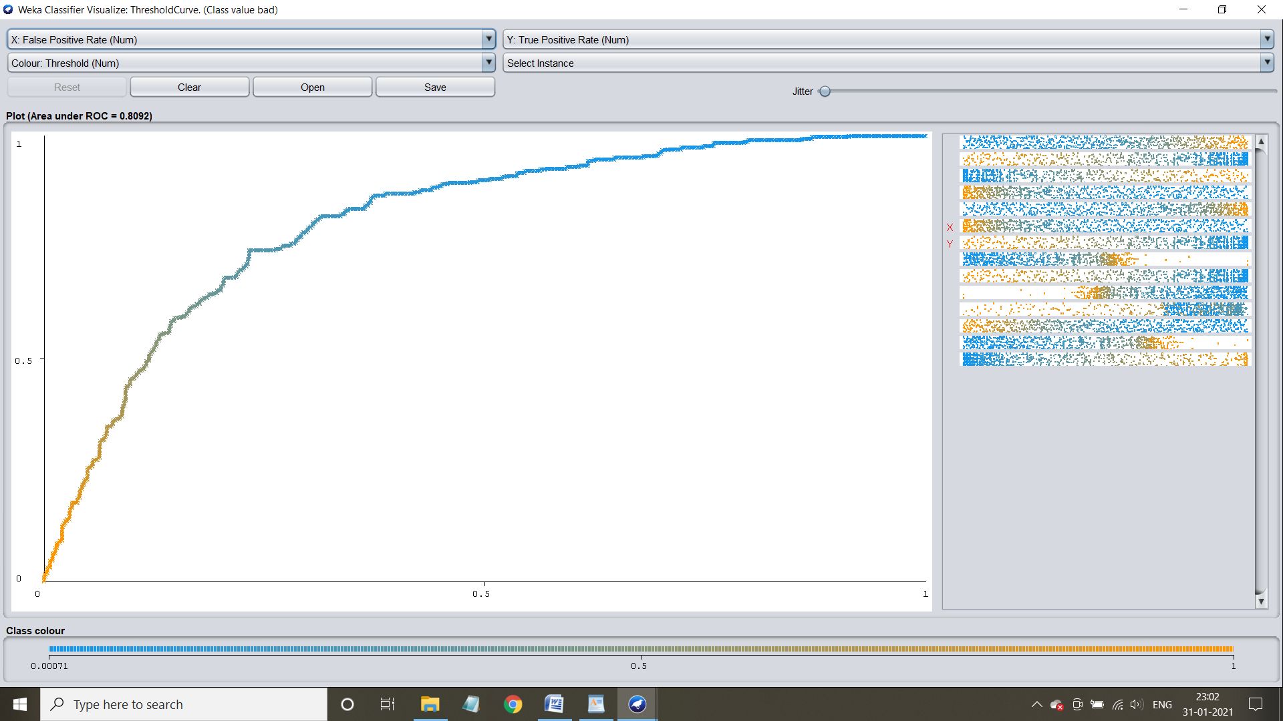

**Application of naive bayes using cross-validation**

**Case1:** application when fold count is 10

Step1 :Select the cross-validation and specify count of fold = 10

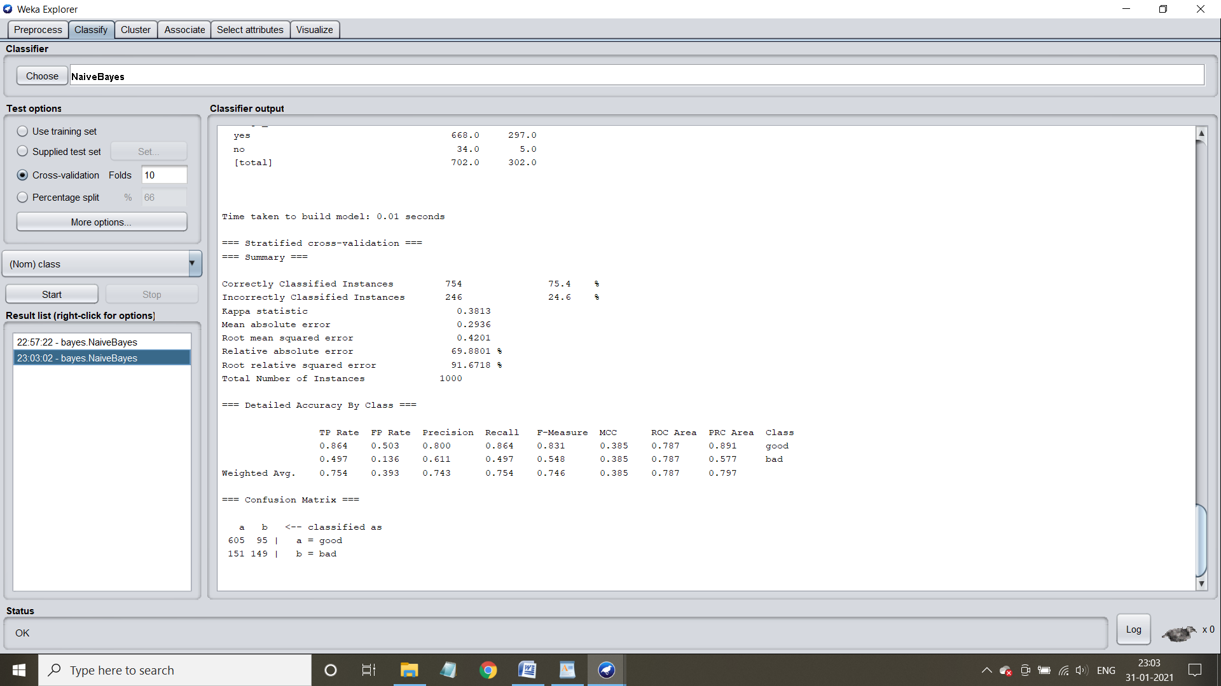

Step 2: Understand the characteristics of the model.Time taken to build model =0.01 seconds

Confusion matrix and accuracy:

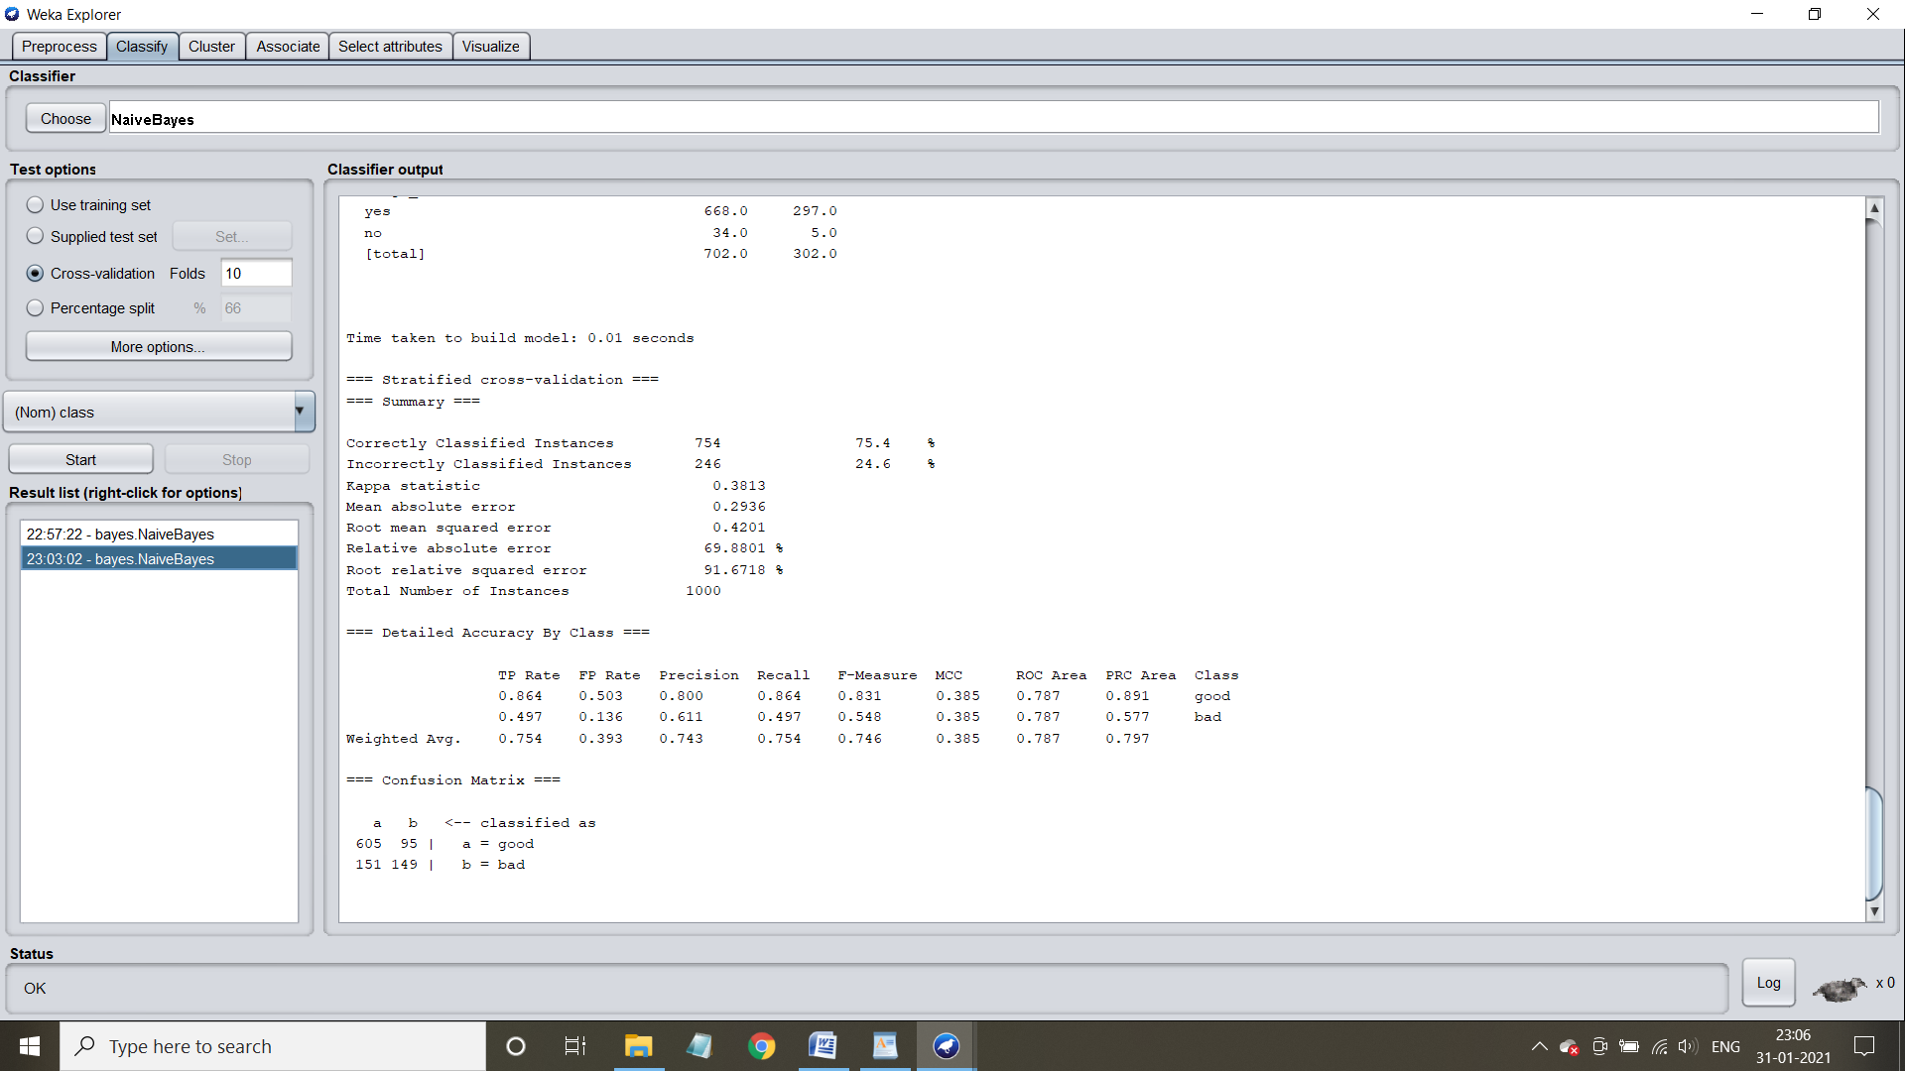

Visualization of the model

**Margin Curve:**

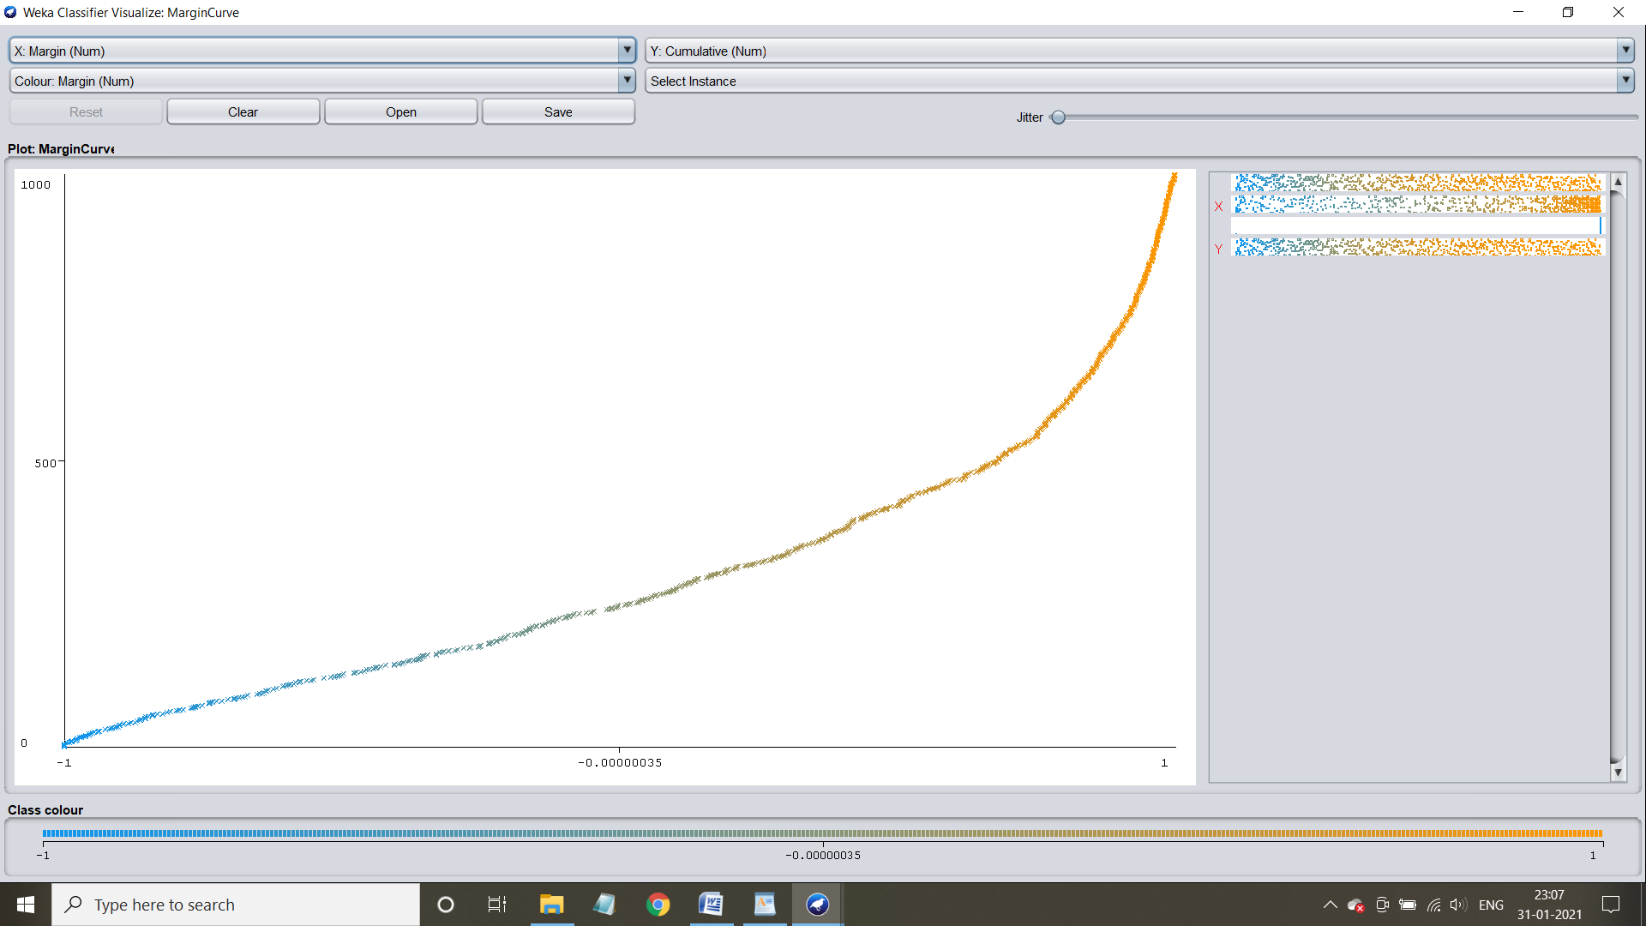

**Threshold curve for the class: Good**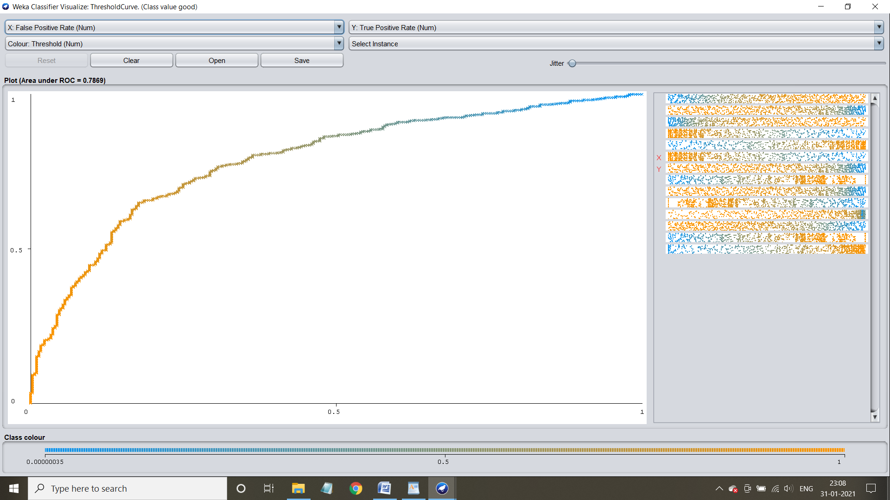

**Threshold curve for the class: Bad**

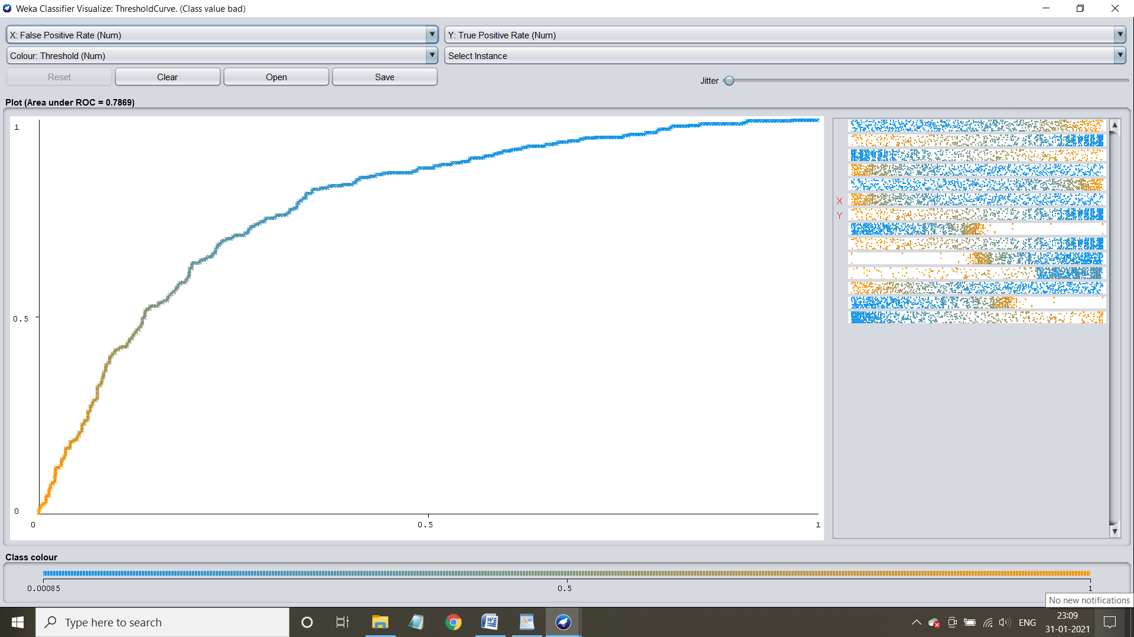

**Case 2:** Application when fold count=8

Step 1: Select the cross-validation and specify count of fold = 8

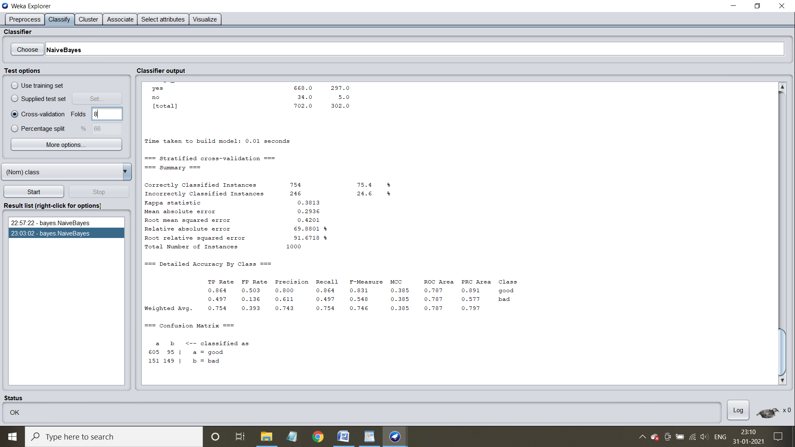

Step 2: Train the machine by clicking start button

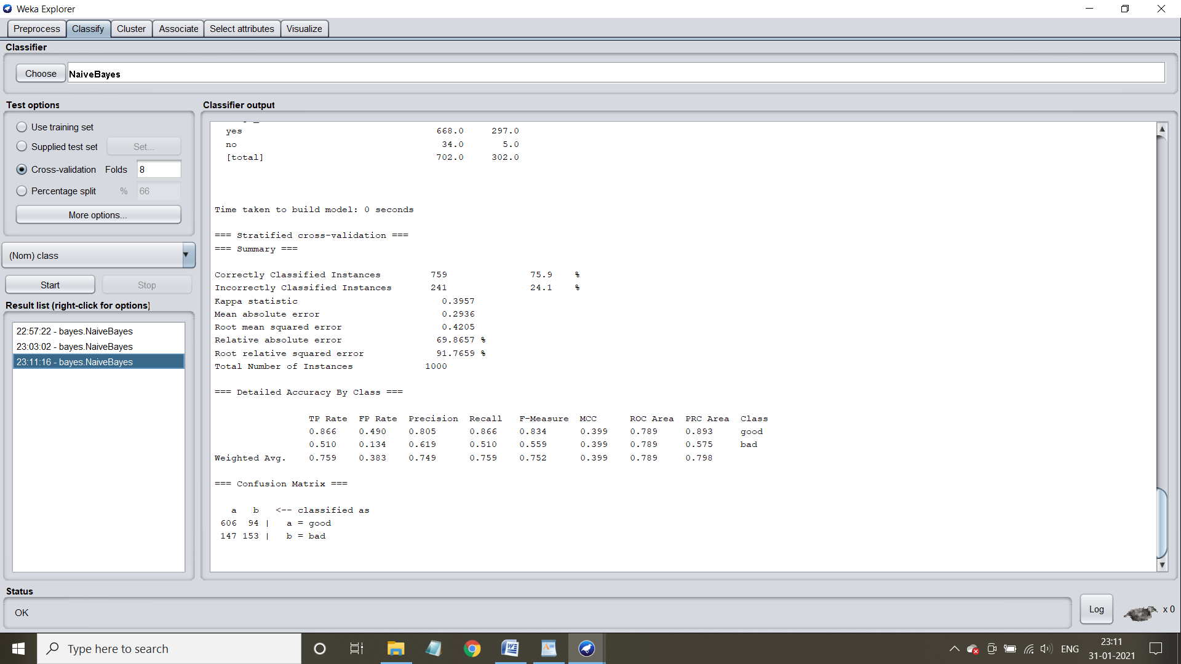

Step 3: Understand the characteristics of the model

Time taken to build the model =0 seconds



Confusion matrix and accuracy :



**Visualization of the model:**

**Margin Curve:**

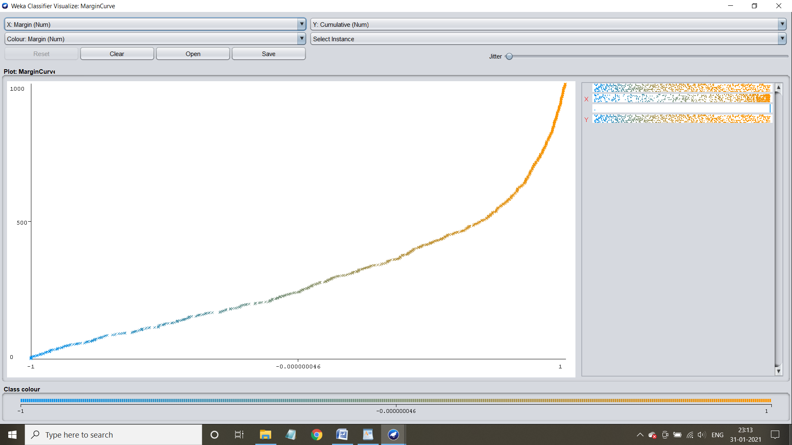

**Threshold curve for class: Good**

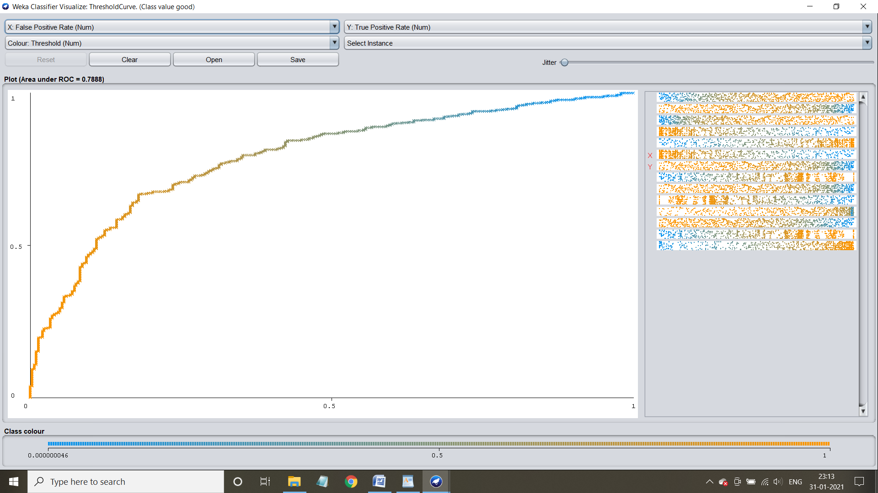

**Threshold curve for class: Bad**

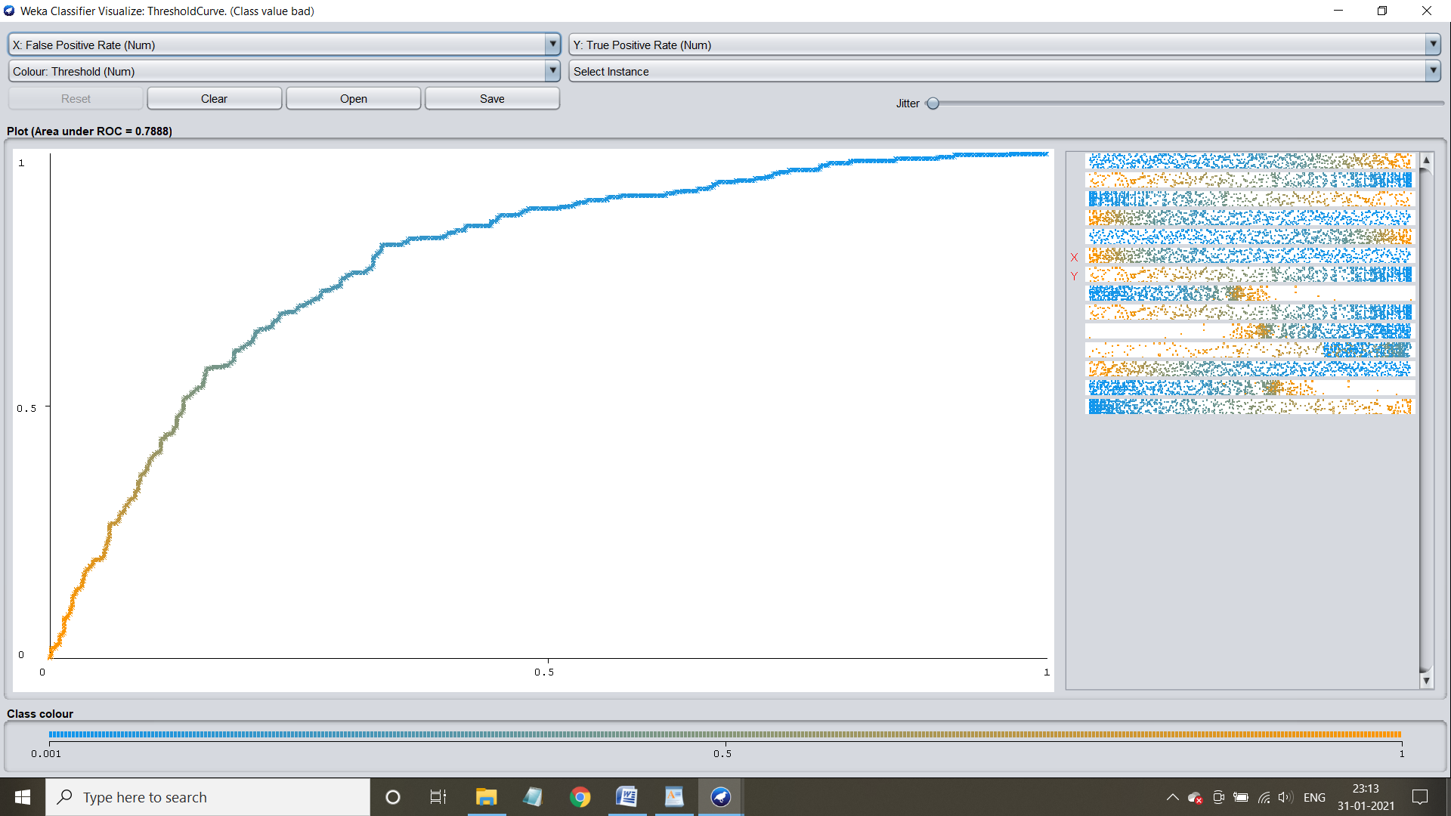

**Application of naive bayes using percentage splitting**

**Case 1:** Application when the percentage splitting is 70%

Step 1: Select the percentage split option and specify the percentage required:70%

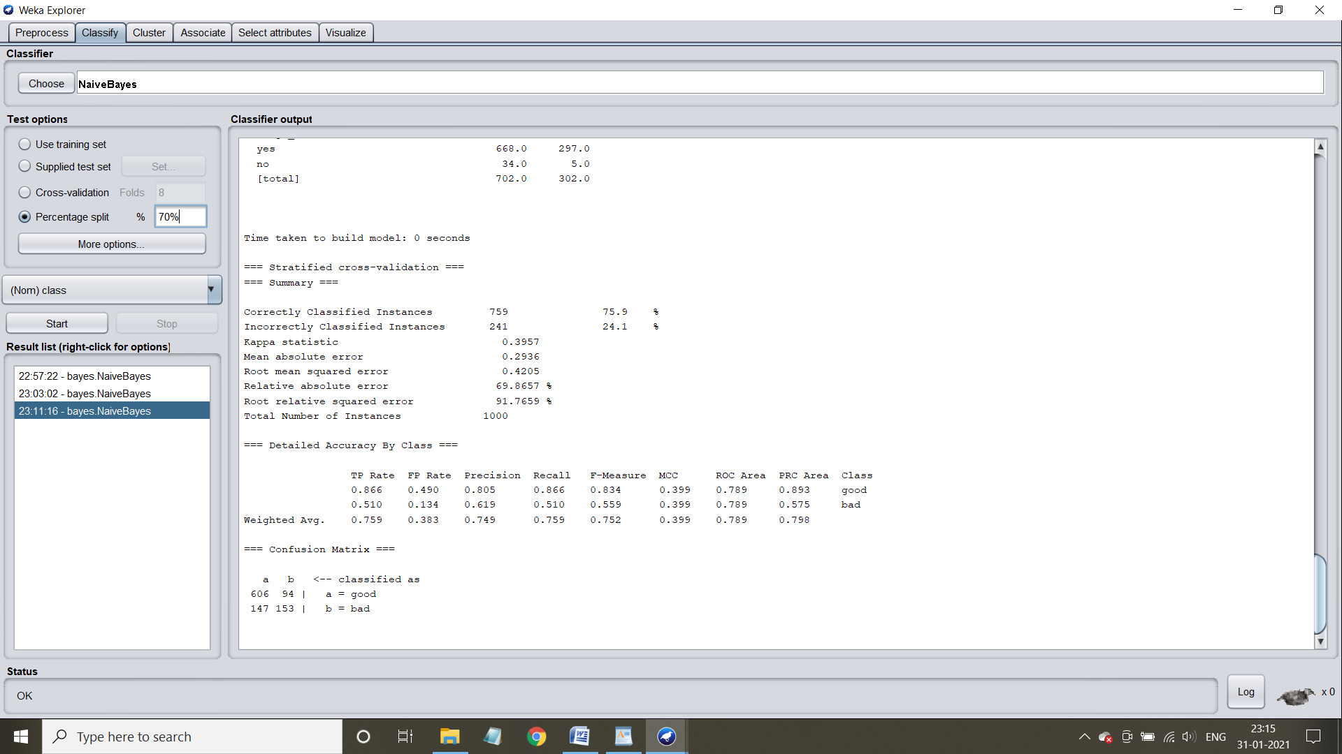

Step 2: Train the machine by hitting start button

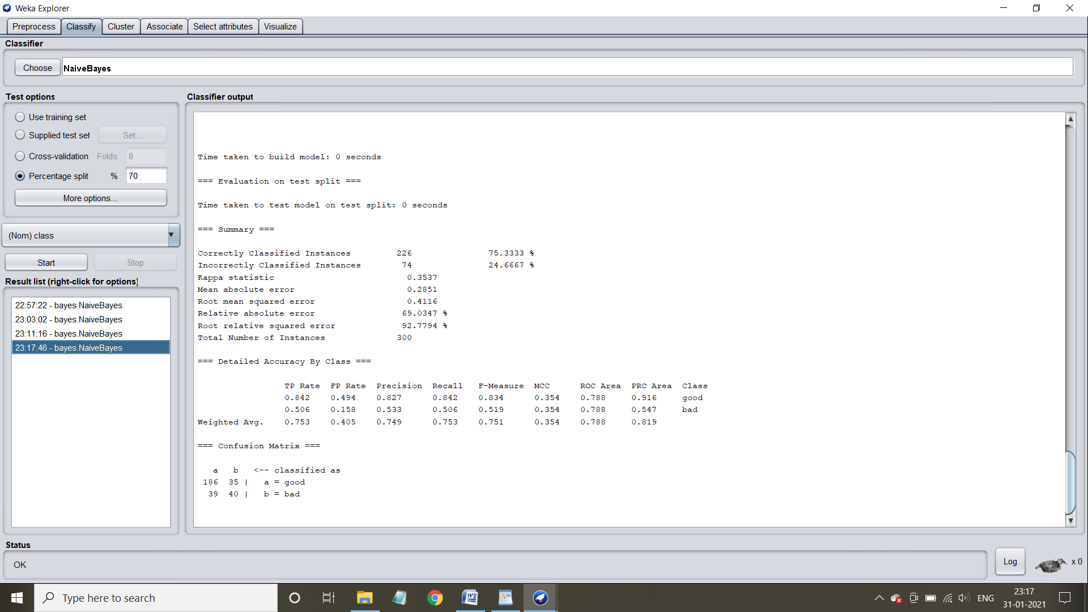

Step 3: Understand the characteristics of the model

Time taken to build the model=0 seconds

Time taken to test the model on the test split = 0 seconds



Confusion matrix and accuracy:



**Virtualization of the model:**

**Margin Curve:**

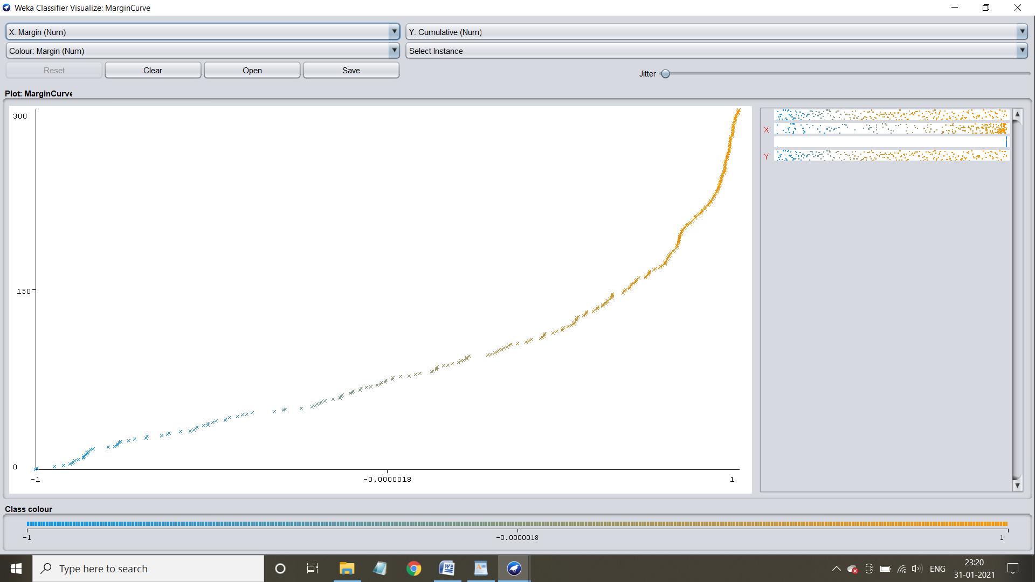

**Threshold curve for class: Good**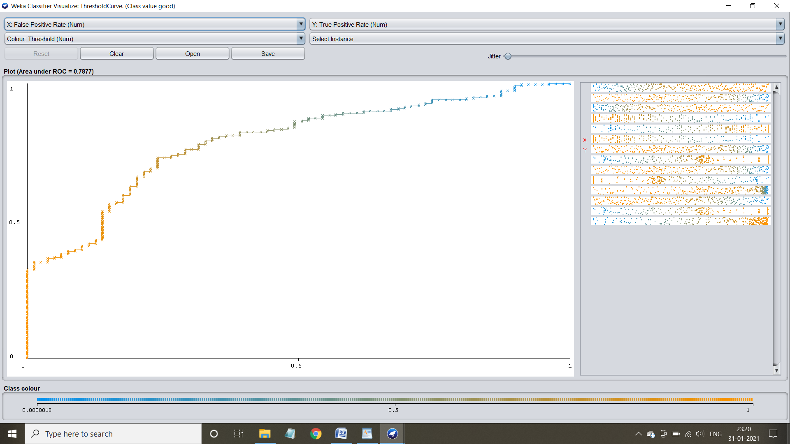

**Threshold curve for class: Bad**

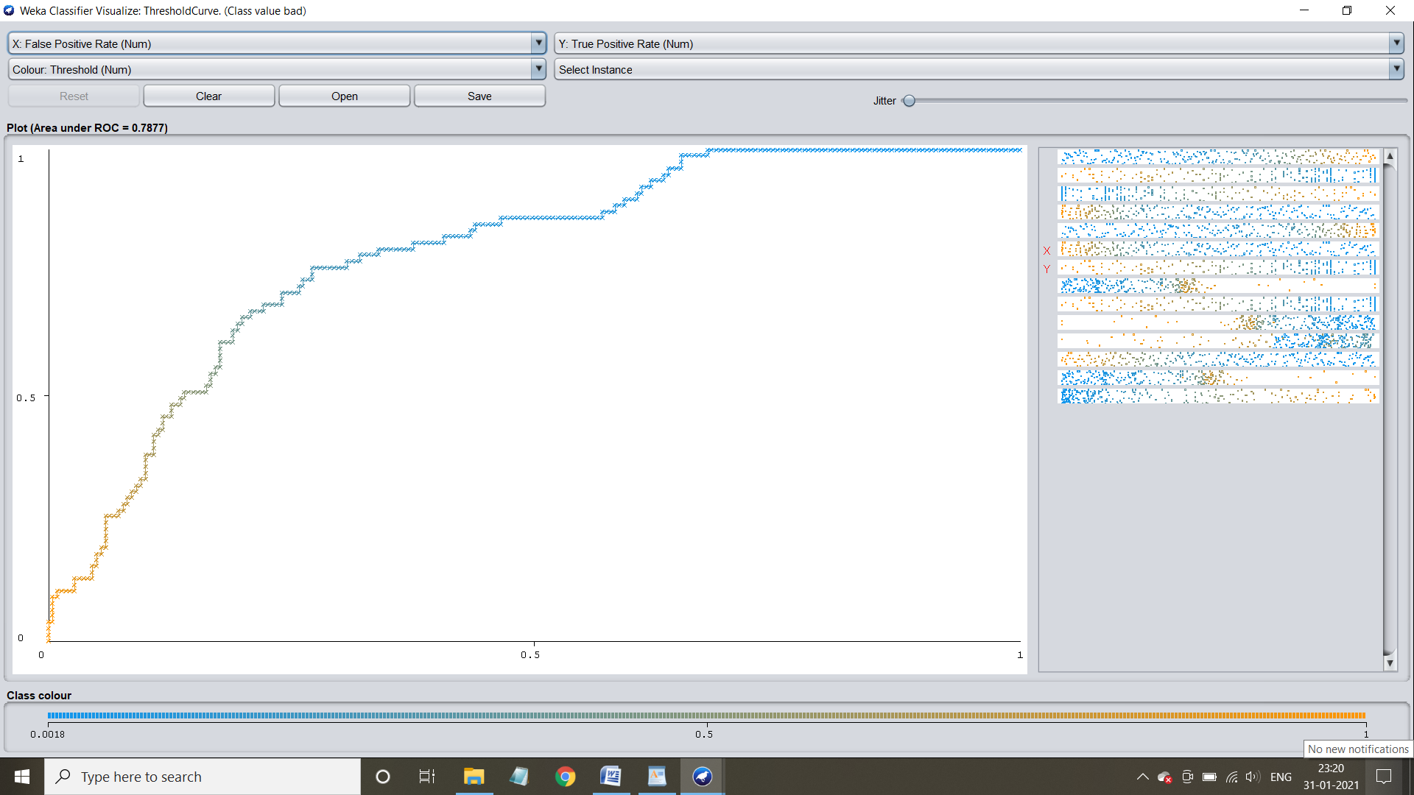

**Case 2:** Application when the splitting percentage is 75%

Step 1: Select the percentage split and specify it as 75% and click start button

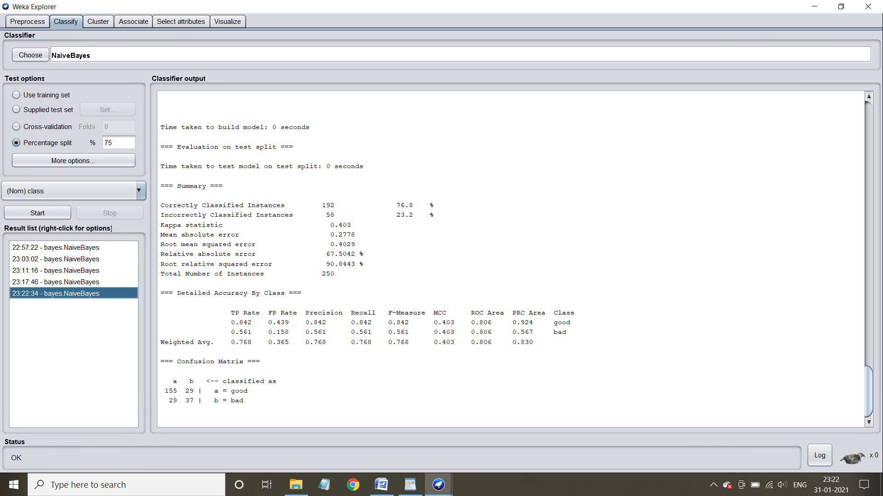

Step 2: Understand the characteristics of the model

Time taken to build the model = 0 seconds

Time taken to test the model on test split : 0 seconds

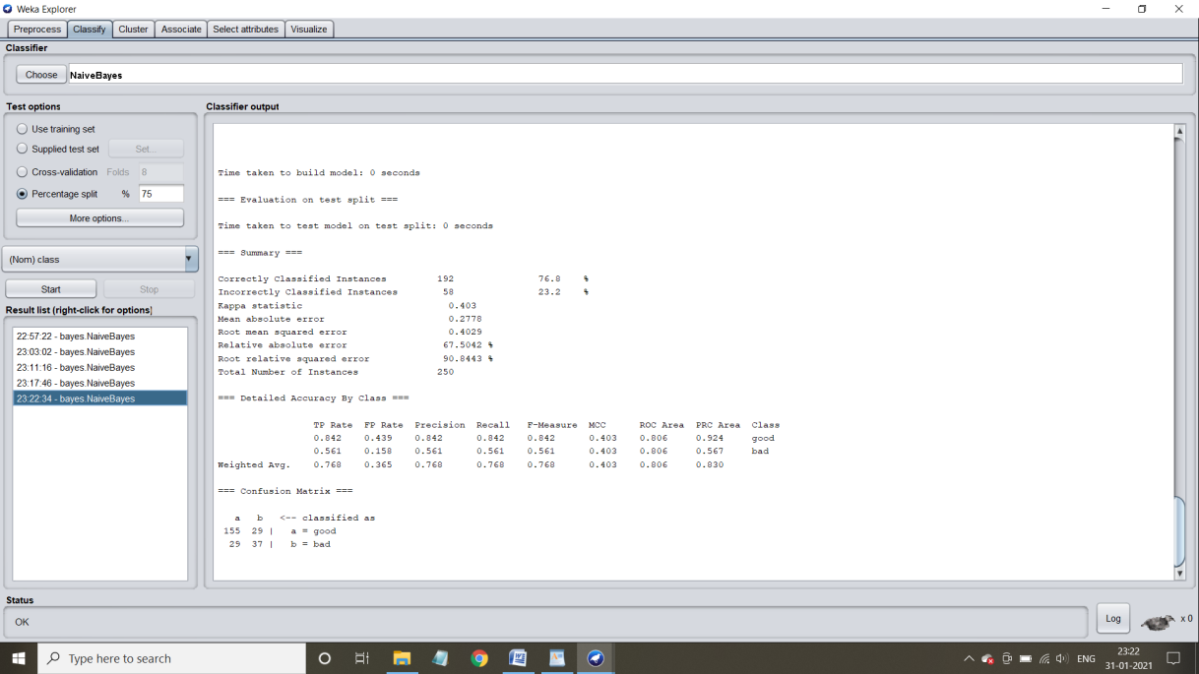

Confusion matrix and accuracy:



**Visualization of the model:**

**Margin Curve:**

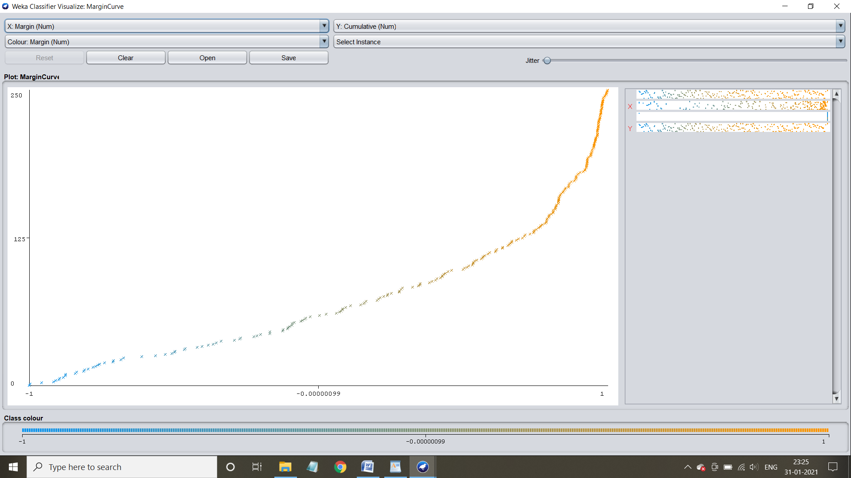

**Threshold curve for class :Good**

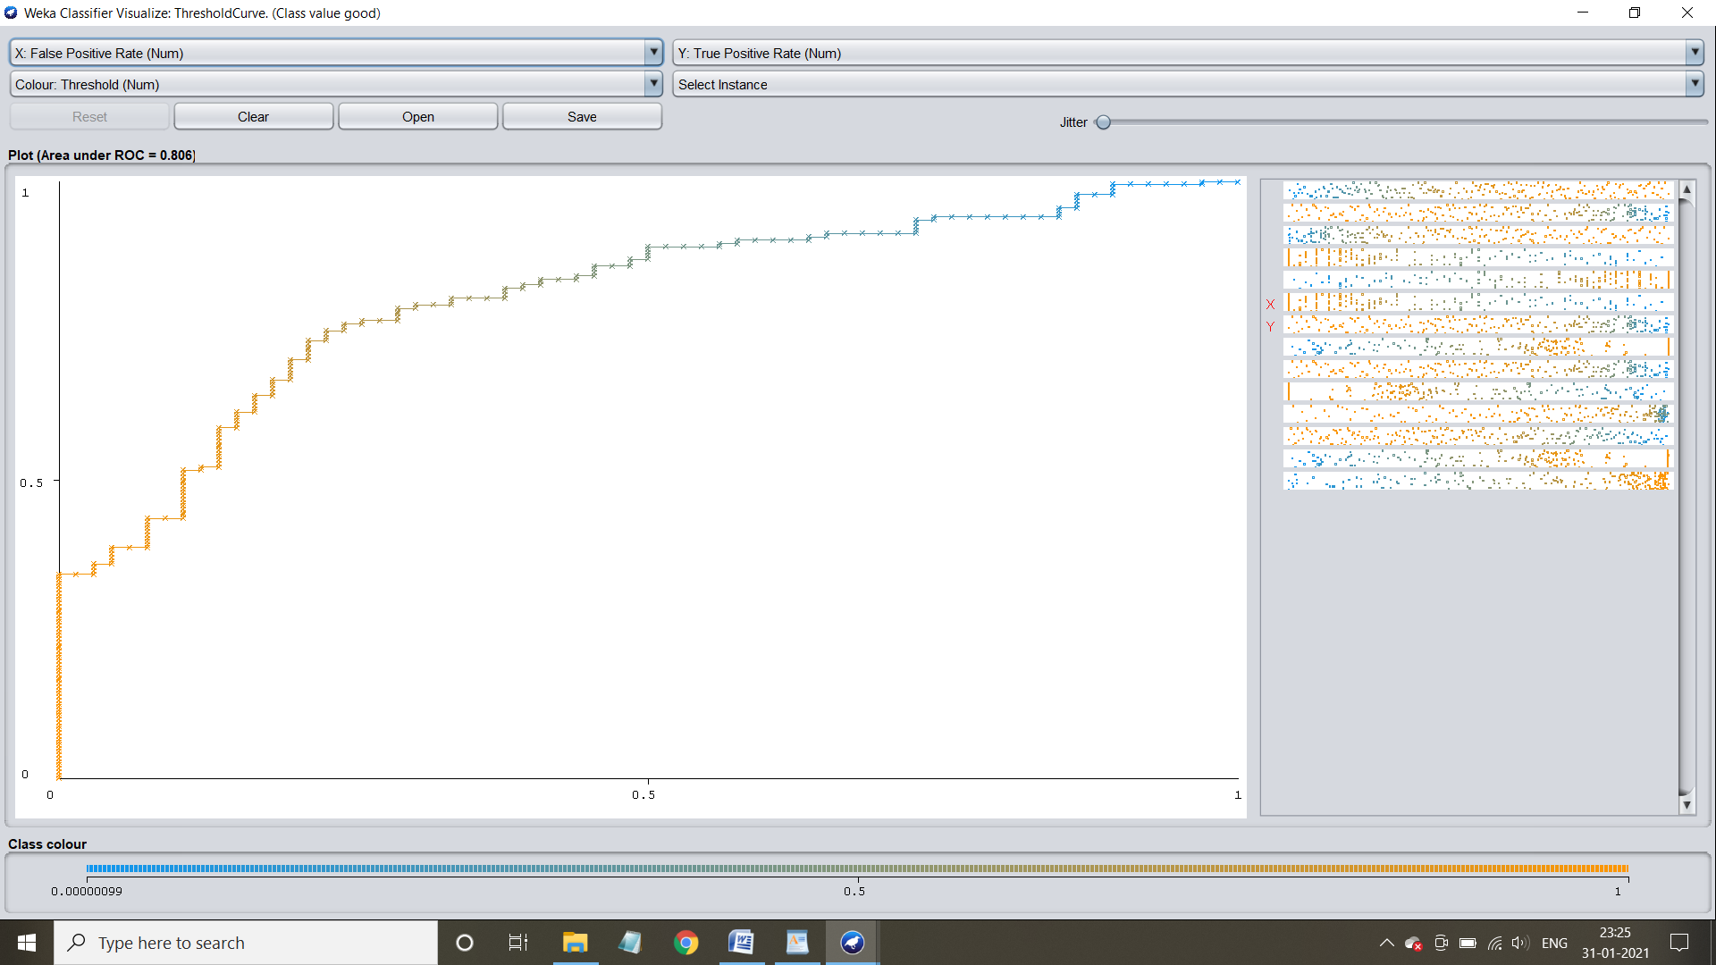

**Threshold curve for class :Bad**

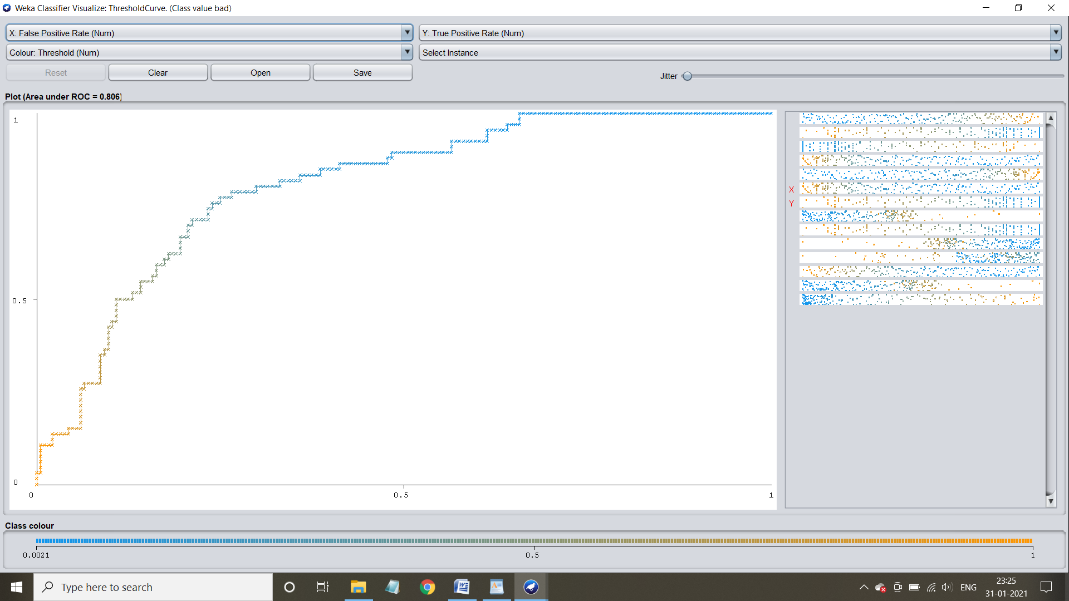

**Case 3: Application when the percentage split is 80%**

Step 1: Select the percentage split and specify it as 80% and click start button

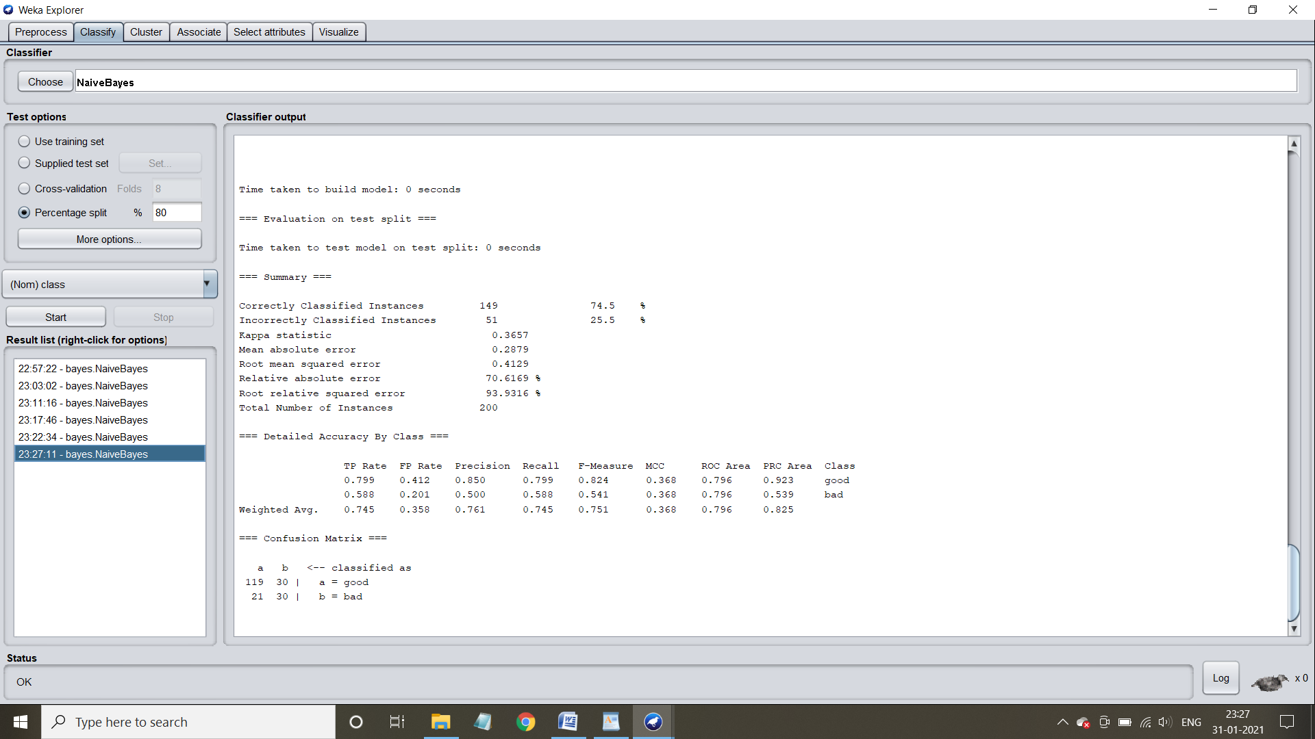

Step 2: Understand the characteristics of model

Time taken to build the model = 0 seconds

Time taken to test the model on test split = 0 seconds



Confusion matrix and accuracy:



**Visualization of the model:**

**Margin Curve:**

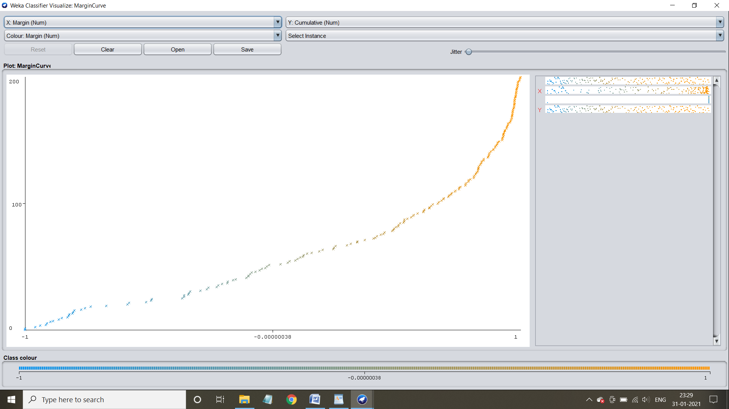

**Threshold curve for class :Good**

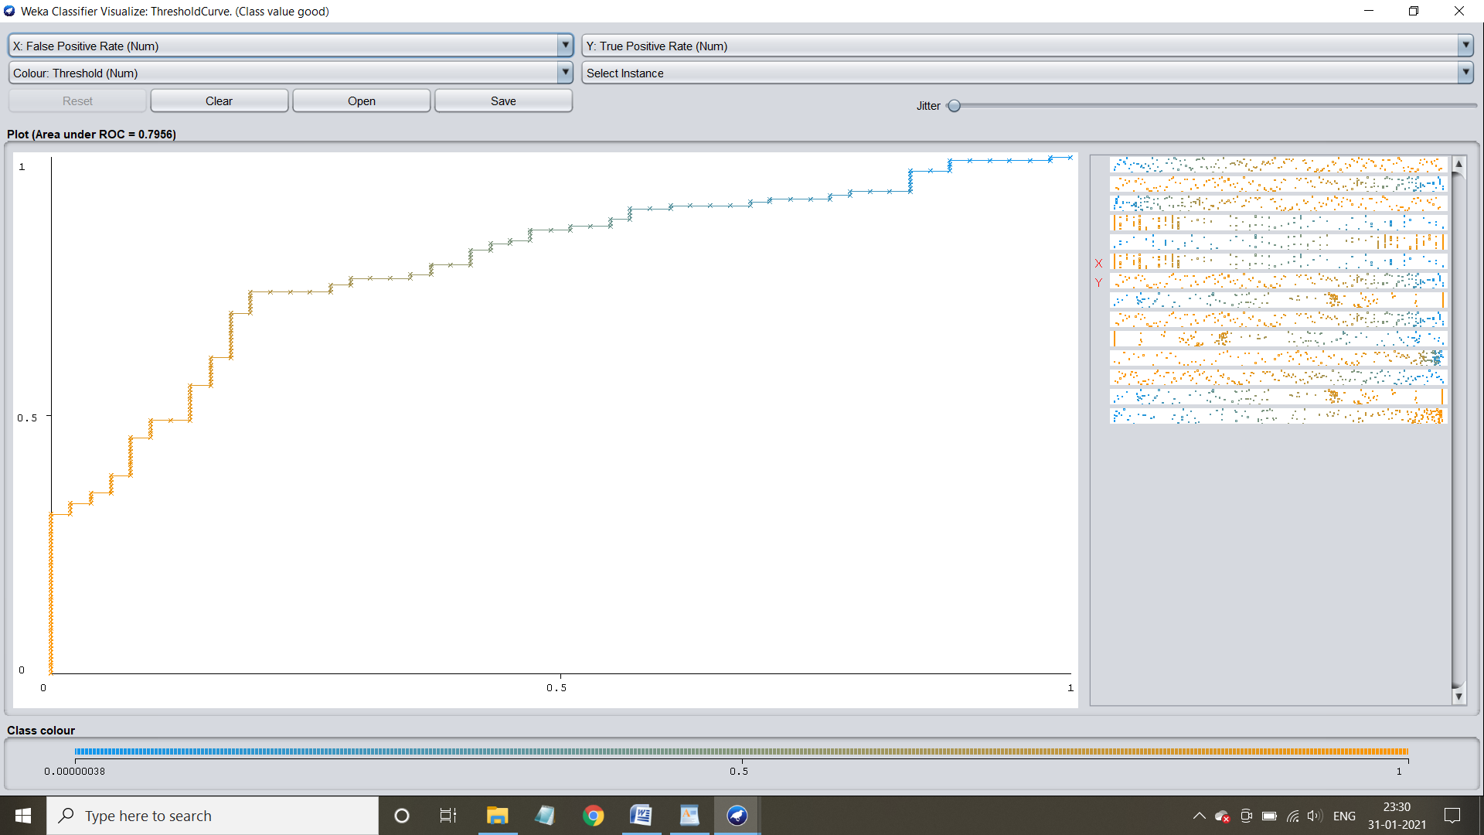

**Threshold curve for class :Bad**

